Jenkins pipelines challenges

1. Declarative Pipeline

Create Pipeline Job
1. Jenkins → New Item
2. Name: hiring-app-challenge
3. Select: Pipeline → OK
4. Scroll to Pipeline section → Pipeline script
5. Paste the script below → Save → Build Now
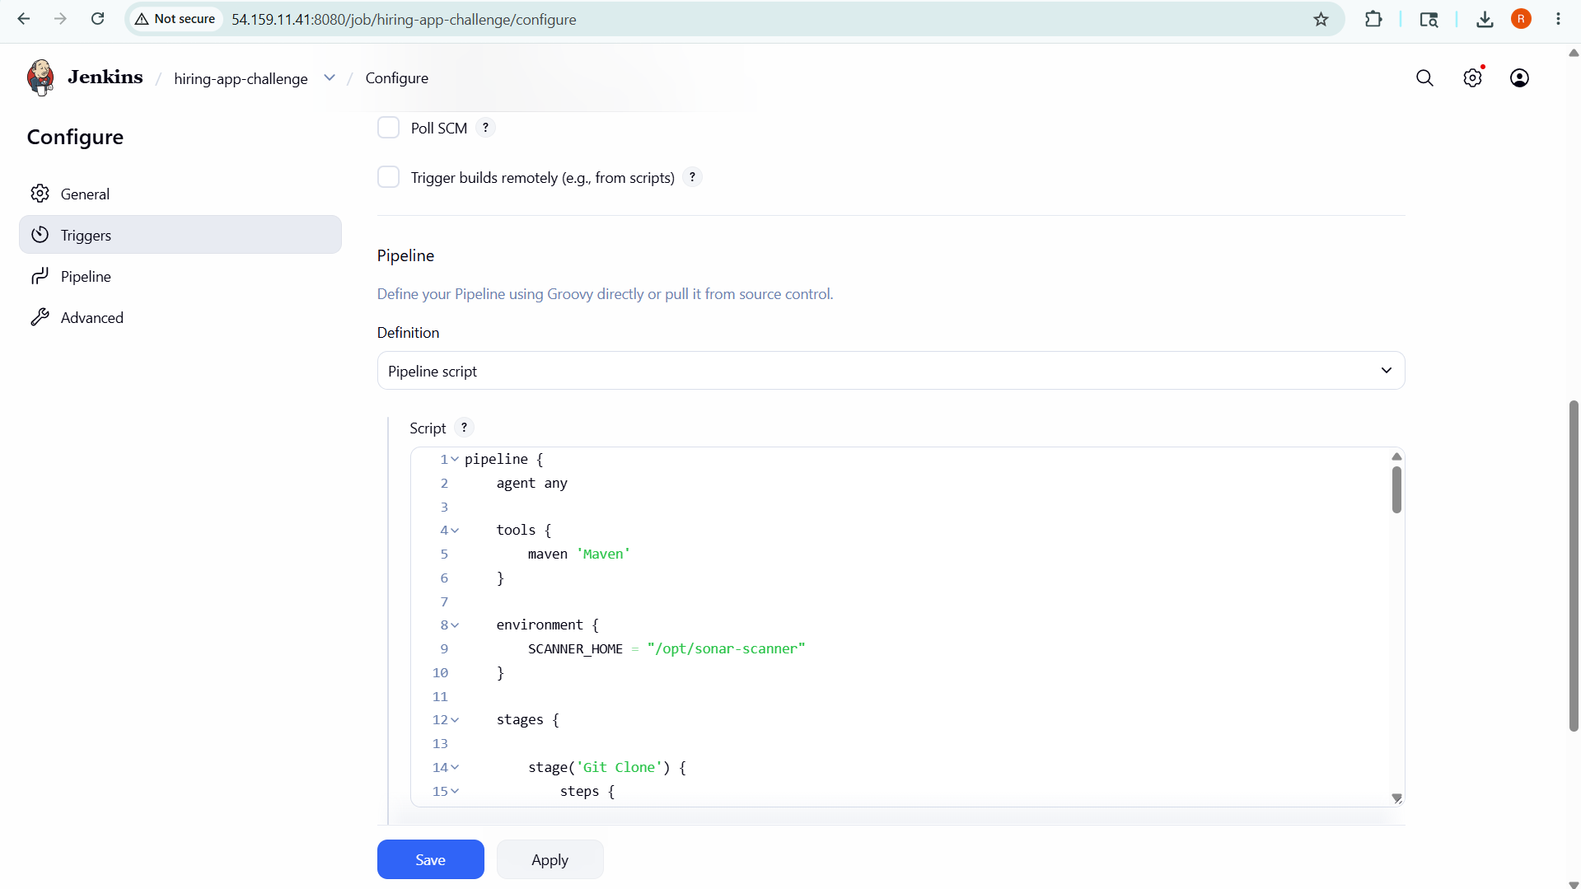

Overview
The Declarative Pipeline uses Jenkins' structured domain-specific language (DSL). It wraps everything inside a pipeline { } block, enforces a clear structure with agent, tools, environment, stages, and post sections, and provides built-in error handling. This is the recommended modern approach for most teams due to its readability and enforced conventions.

Key Features
• agent any — runs on any available Jenkins node
• tools block auto-installs Maven and adds it to PATH
• environment block declares SCANNER_HOME globally for all stages
• post block handles success/failure Slack notifications cleanly
• nexusArtifactUploader dynamically resolves the WAR file using shell script

Jenkinsfile

pipeline {
agent any

tools {
maven 'Maven'
}

environment {
SCANNER_HOME = "/opt/sonar-scanner"
}

stages {

stage('Git Clone') {
steps {
git branch: 'main',
url: 'https://github.com/betawins/hiring-app.git'
}
}

stage('SonarQube Analysis') {
steps {
sh """
${SCANNER_HOME}/bin/sonar-scanner \
-Dsonar.projectKey=hiring-app \
-Dsonar.projectName=hiring-app \
-Dsonar.sources=. \
-Dsonar.java.binaries=.
"""
}
}

stage('Maven Build') {
steps {
sh 'mvn clean package'
}
}

stage('Nexus Upload') {
steps {
script {
def warFile = sh(
script: "ls target/*.war | head -1",
returnStdout: true
).trim()

nexusArtifactUploader(
nexusVersion: 'nexus3',
protocol: 'http',
nexusUrl: '34.230.5.234:8081',
groupId: 'com.hiring',
version: "${env.BUILD_NUMBER}",
repository: 'hiring-releases',
credentialsId: 'nexus-creds',
artifacts: [[
artifactId: 'hiring-app',
classifier: '',
file: warFile,
type: 'war'
]]
)
}
}
}

stage('Deploy On Tomcat') {
steps {
script {
def warFile = sh(
script: "ls target/*.war | head -1",
returnStdout: true
).trim()

deploy adapters: [
tomcat9(
credentialsId: 'tomcat-idpass',
path: '',
url: 'http://44.195.83.108:8082/manager/html'
)
],
contextPath: 'hiring',
war: warFile
}
}
}
}

post {
success {
slackSend(
channel: '#hiring-app',
color: 'good',
message: "SUCCESS: ${env.JOB_NAME} Build ${env.BUILD_NUMBER}"
)
}
failure {
slackSend(
channel: '#hiring-app',
color: 'danger',
message: "FAILED: ${env.JOB_NAME} Build ${env.BUILD_NUMBER}"
)
}
}
}

Post-Build Notifications
On success: Slack sends a green "good" message with job name and build number to #hiring-app.
On failure: Slack sends a red "danger" message with job name and build number to #hiring-app.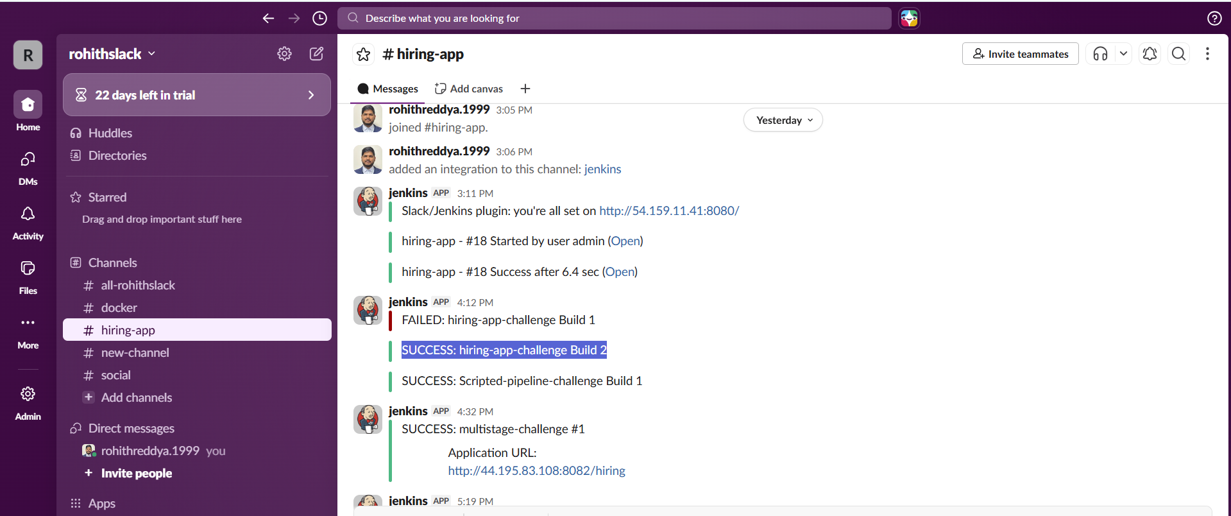

2. Scripted Pipeline

Create Pipeline Job
1. Jenkins → New Item
2. Name:Scripted-pipeline-challenge
3. Select: Pipeline → OK
4. Scroll to Pipeline section → Pipeline script
5. Paste the script below → Save → Build Now
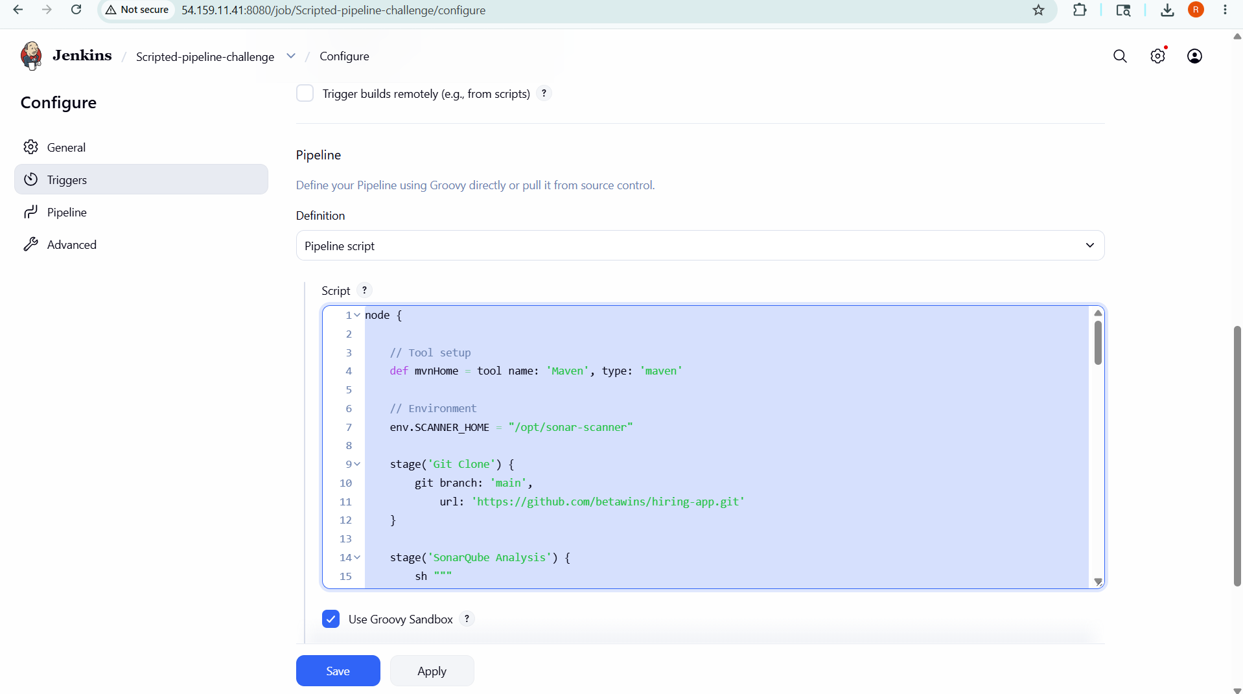

Overview
The Scripted Pipeline is written in pure Groovy and starts with a node { } block instead of the declarative pipeline { } wrapper. It offers maximum programmatic flexibility — you can use any Groovy language construct including loops, conditionals, and complex logic. Error handling is done explicitly using try/catch/finally blocks.

Key Differences from Declarative
• Starts with node { } instead of pipeline { }
• Tool installation done via tool() function call at the top of the node block
• Environment variables set directly via env.VARIABLE = "value"
• No automatic post block — error handling uses try/catch/finally
• More verbose but more flexible for complex branching logic

Jenkinsfile

node {

// Tool setup

def mvnHome = tool name: 'Maven', type: 'maven'

// Environment

env.SCANNER_HOME = "/opt/sonar-scanner"

stage('Git Clone') {

git branch: 'main',

url: 'https://github.com/betawins/hiring-app.git'

}

stage('SonarQube Analysis') {

sh """

${env.SCANNER_HOME}/bin/sonar-scanner \

-Dsonar.projectKey=hiring-app \

-Dsonar.projectName=hiring-app \

-Dsonar.sources=. \

-Dsonar.java.binaries=.

"""

}

stage('Maven Build') {

sh "${mvnHome}/bin/mvn clean package"

}

stage('Nexus Upload') {

script {

def warFile = sh(

script: "ls target/*.war | head -1",

returnStdout: true

).trim()

nexusArtifactUploader(

nexusVersion: 'nexus3',

protocol: 'http',

nexusUrl: '34.230.5.234:8081',

groupId: 'com.hiring',

version: "${env.BUILD_NUMBER}",

repository: 'hiring-releases',

credentialsId: 'nexus-creds',

artifacts: [[

artifactId: 'hiring-app',

classifier: '',

file: warFile,

type: 'war'

]]

)

}

}

stage('Deploy On Tomcat') {

script {

def warFile = sh(

script: "ls target/*.war | head -1",

returnStdout: true

).trim()

deploy adapters: [

tomcat9(

credentialsId: 'tomcat-idpass',

path: '',

url: 'http://44.195.83.108:8082/manager/text'

)

],

contextPath: 'hiring',

war: warFile

}

}

// Post actions

try {

slackSend(

channel: '#hiring-app',

color: 'good',

message: "SUCCESS: ${env.JOB_NAME} Build ${env.BUILD_NUMBER}"

)

} catch (err) {

slackSend(

channel: '#hiring-app',

color: 'danger',

message: "FAILED: ${env.JOB_NAME} Build ${env.BUILD_NUMBER}"

)

throw err

}

}

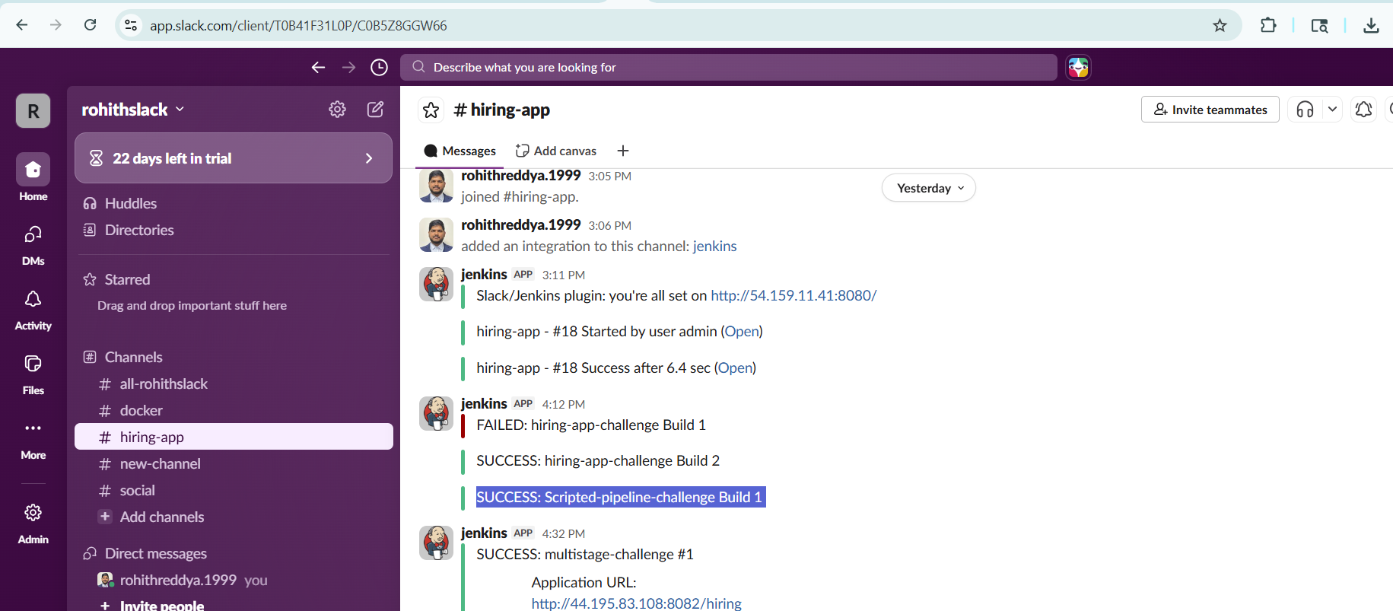

3. Multi-Stage Pipeline

Create Pipeline Job
1. Jenkins → New Item
2. Name:multistage-challenge
3. Select: Pipeline → OK
4. Scroll to Pipeline section → Pipeline script
5. Paste the script below → Save → Build Now

Overview
The Multi-Stage Pipeline is a Declarative Pipeline that explicitly separates every concern into its own named stage. Unlike a basic pipeline, this version uses agent { label 'built-in' } to pin execution to the Jenkins built-in node, and ensures every CI/CD activity — clone, build, quality gate, artifact upload, and deployment — is a discrete, named, and trackable stage visible in the Jenkins Blue Ocean / stage view.

Key Features
• agent label: built-in — pins pipeline to the built-in Jenkins controller node
• Five clearly separated stages for maximum observability in Jenkins UI
• SonarQube analysis runs after Maven build to ensure binaries are available
• Nexus upload and Tomcat deployment are separate stages for independent retry
• Success notification includes the live application URL for quick verification

Jenkinsfile

pipeline {

agent {

label 'built-in'

}

tools {

maven 'Maven'

}

environment {

scannerHome = "/opt/sonar-scanner"

}

stages {

stage('Clone Code') {

steps {

git branch: 'main',

url: 'https://github.com/betawins/hiring-app.git'

}

}

stage('Build Application') {

steps {

sh 'mvn clean package'

}

}

stage('SonarQube Analysis') {

steps {

sh """

${scannerHome}/bin/sonar-scanner \

-Dsonar.projectKey=hiring-app \

-Dsonar.projectName=hiring-app \

-Dsonar.sources=. \

-Dsonar.java.binaries=.

"""

}

}

stage('Upload Artifact To Nexus') {

steps {

script {

def warFile = sh(

script: "ls target/*.war | head -1",

returnStdout: true

).trim()

nexusArtifactUploader(

nexusVersion: 'nexus3',

protocol: 'http',

nexusUrl: '34.230.5.234:8081',

repository: 'hiring-releases',

credentialsId: 'nexus-creds',

groupId: 'com.hiring',

version: "${BUILD_NUMBER}",

artifacts: [

[

artifactId: 'hiring-app',

classifier: '',

file: warFile,

type: 'war'

]

]

)

}

}

}

stage('Deploy To Tomcat') {

steps {

script {

def warFile = sh(

script: "ls target/*.war | head -1",

returnStdout: true

).trim()

deploy adapters: [

tomcat9(

credentialsId: 'tomcat-idpass',

path: '',

url: 'http://44.195.83.108:8082/manager/text'

)

],

contextPath: '/hiring',

war: warFile

}

}

}

}

post {

success {

slackSend(

channel: '#hiring-app',

color: 'good',

message: """

SUCCESS: ${JOB_NAME} #${BUILD_NUMBER}

Application URL:

http://44.195.83.108:8082/hiring

"""

)

}

failure {

slackSend(

channel: '#hiring-app',

color: 'danger',

message: """

FAILED: ${JOB_NAME} #${BUILD_NUMBER}

Build URL:

${BUILD_URL}

"""

)

}

}

}

Post-Build Notifications
On success: Slack message includes both the job name/build number and the live application URL (http://44.195.83.108:8082/hiring) for immediate access.
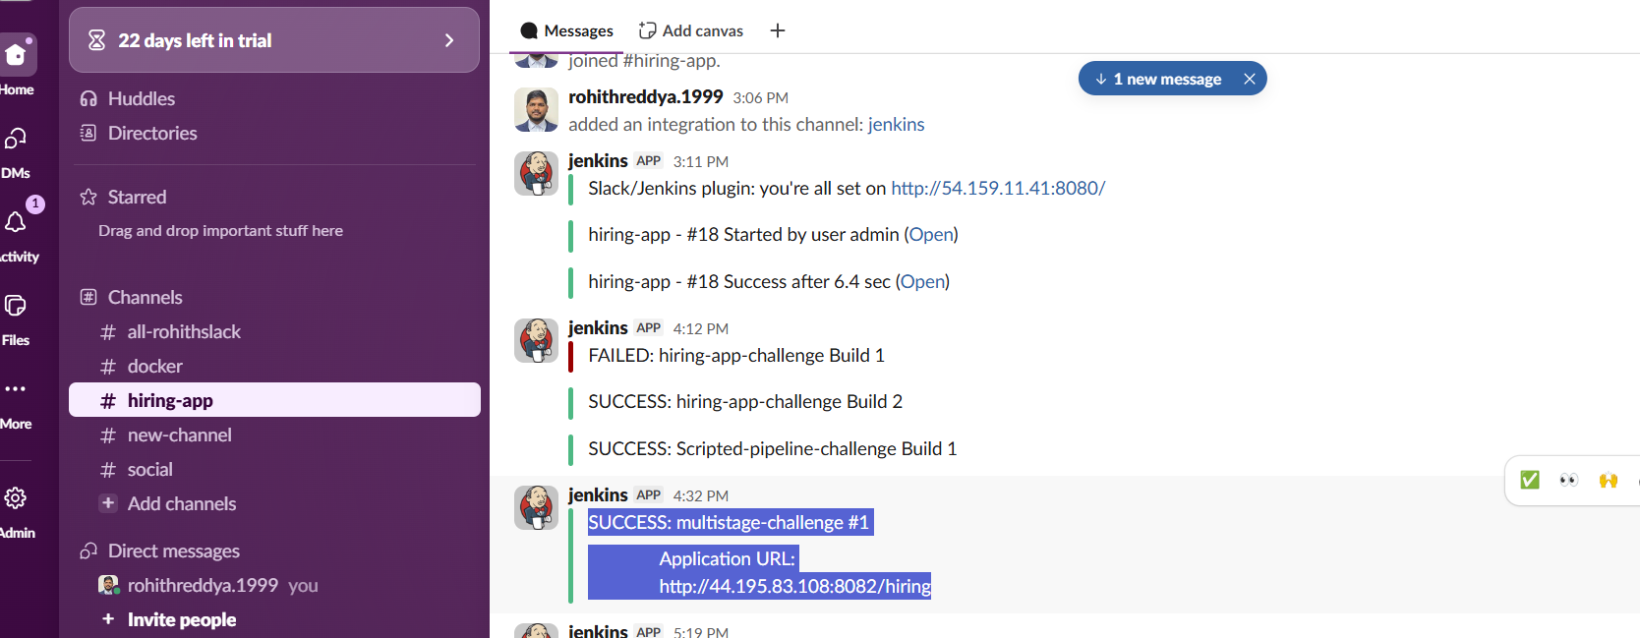

4. Parallel Stage Pipeline

Create Pipeline Job
1. Jenkins → New Item
2. Name:parallel-stage-pipeline-challenge
3. Select: Pipeline → OK
4. Scroll to Pipeline section → Pipeline script
5. Paste the script below → Save → Build Now

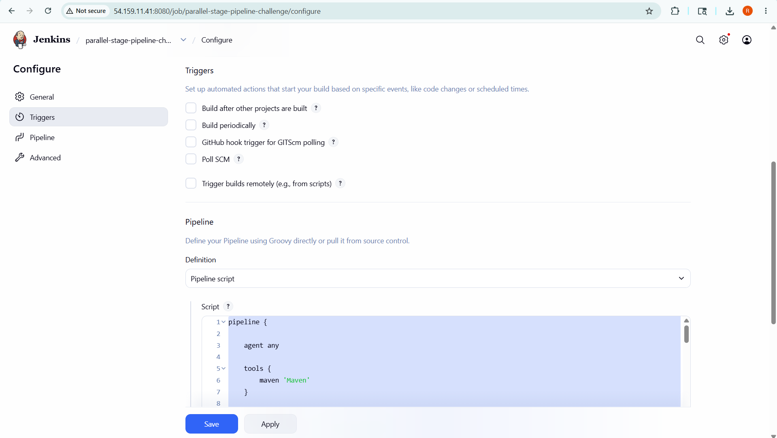

Overview
The Parallel Stage Pipeline optimizes CI execution time by running the Maven build, SonarQube static analysis, and artifact listing simultaneously within a single "Parallel Execution" stage. This is achieved using the parallel { } directive inside a stage. While the Nexus upload and Tomcat deployment must still run sequentially (they depend on the built artifact), the parallel block dramatically reduces the total wall-clock time for the pipeline.

Parallel Block Design
Three branches execute concurrently inside the Parallel Execution stage:
• Build — runs mvn clean package to compile and package the WAR
• SonarQube Analysis — uses withSonarQubeEnv() wrapper for environment injection, runs sonar-scanner
• Check Artifact — lists target/ directory contents for diagnostic purposes (fails gracefully with || true)

After the parallel block completes, the pipeline continues sequentially with Nexus upload and Tomcat deployment, which require the WAR artifact produced by the Build branch.

Jenkinsfile

pipeline {

agent any

tools {

maven 'Maven'

}

environment {

scannerHome = "/opt/sonar-scanner"

}

stages {

stage('Clone Code') {

steps {

git branch: 'main',

url: 'https://github.com/betawins/hiring-app.git'

}

}

stage('Parallel Execution') {

parallel {

stage('Build') {

steps {

sh 'mvn clean package'

}

}

stage('SonarQube Analysis') {

steps {

withSonarQubeEnv('SonarQube') {

sh """

${scannerHome}/bin/sonar-scanner \

-Dsonar.projectKey=hiring-app \

-Dsonar.projectName=hiring-app \

-Dsonar.sources=. \

-Dsonar.java.binaries=.

"""

}

}

}

stage('Check Artifact') {

steps {

sh 'ls -ltr target || true'

}

}

}

}

stage('Upload Artifact To Nexus') {

steps {

script {

def warFile = sh(

script: "ls target/*.war | head -1",

returnStdout: true

).trim()

nexusArtifactUploader(

nexusVersion: 'nexus3',

protocol: 'http',

nexusUrl: '34.230.5.234:8081',

repository: 'hiring-releases',

credentialsId: 'nexus-creds',

groupId: 'com.hiring',

version: "${BUILD_NUMBER}",

artifacts: [

[

artifactId: 'hiring-app',

classifier: '',

file: warFile,

type: 'war'

]

]

)

}

}

}

stage('Deploy To Tomcat') {

steps {

script {

def warFile = sh(

script: "ls target/*.war | head -1",

returnStdout: true

).trim()

deploy adapters: [

tomcat9(

credentialsId: 'tomcat-idpass',

path: '',

url: 'http://44.195.83.108:8082/manager/text'

)

],

contextPath: '/hiring',

war: warFile

}

}

}

}

post {

success {

slackSend(

channel: '#hiring-app',

color: 'good',

message: """

SUCCESS: ${JOB_NAME} #${BUILD_NUMBER}

Application URL:

http://44.195.83.108:8082/hiring

Build URL:

${BUILD_URL}

"""

)

}

failure {

slackSend(

channel: '#hiring-app',

color: 'danger',

message: """

FAILED: ${JOB_NAME} #${BUILD_NUMBER}

Check Build:

${BUILD_URL}

"""

)

}

}

}

Post-Build Notifications
On success: Slack message includes both the job name/build number and the live application URL (http://44.195.83.108:8082/hiring) for immediate access.
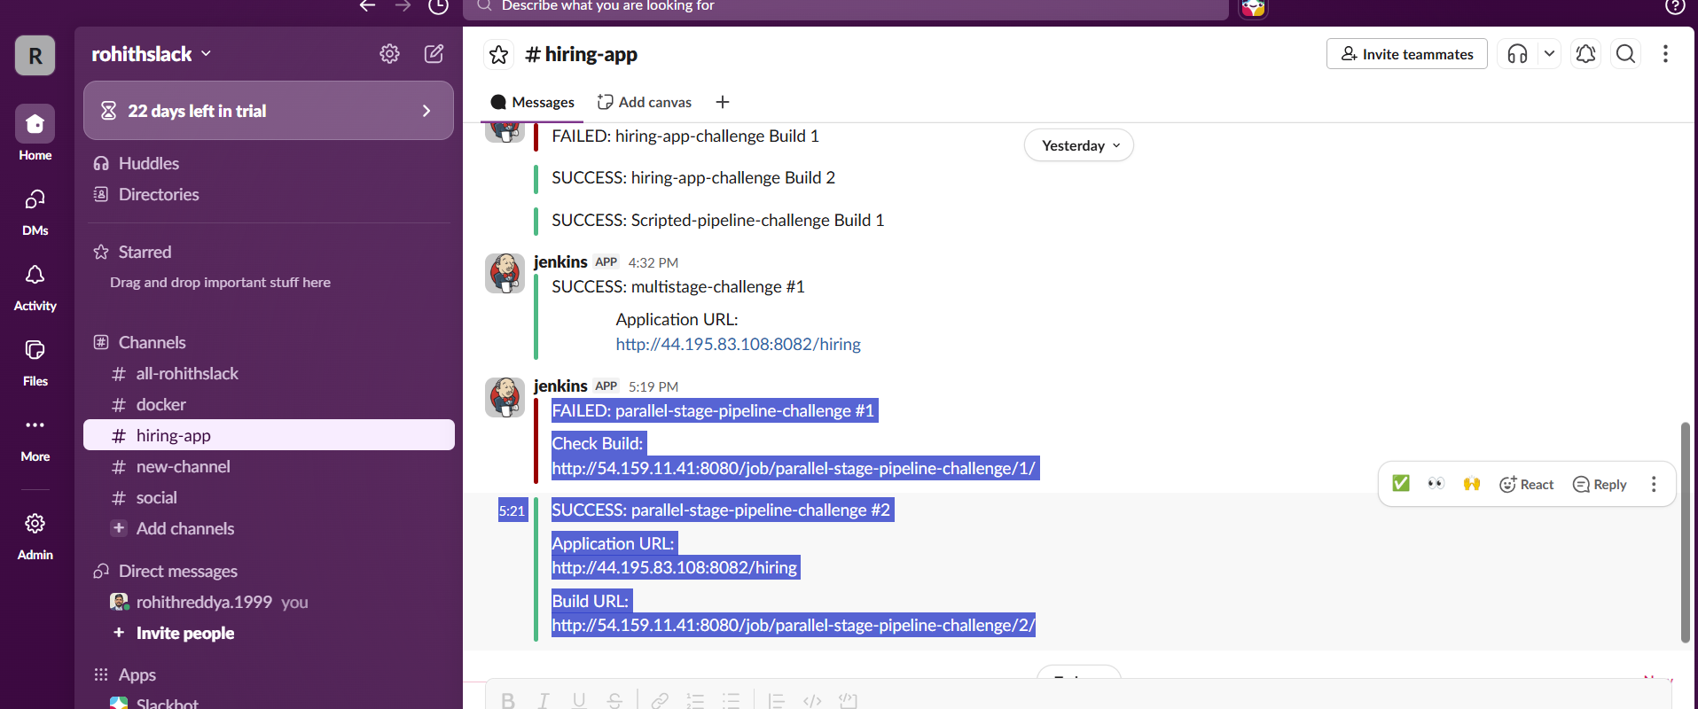

Pipeline Comparison
The table below summarizes the key differences and use cases for each pipeline type implemented in this challenge.

Feature | Declarative | Scripted | Multi-Stage | Parallel
Syntax Style | Declarative DSL | Groovy Scripted | Declarative DSL | Declarative DSL
Agent | agent any | node { } | agent label | agent any
Error Handling | Built-in post { } | try/catch | Built-in post { } | Built-in post { }
Parallelism | Sequential | Sequential | Sequential | Parallel block
Stage Count | 5 stages | 5 stages | 5 stages | 4+3 parallel
SonarQube | Manual env var | Manual env var | Manual env var | withSonarQubeEnv
Slack Notif. | Yes | Yes | Yes + App URL | Yes + App URL
Best For | Standard teams | Complex logic | Observability | Speed optimization

